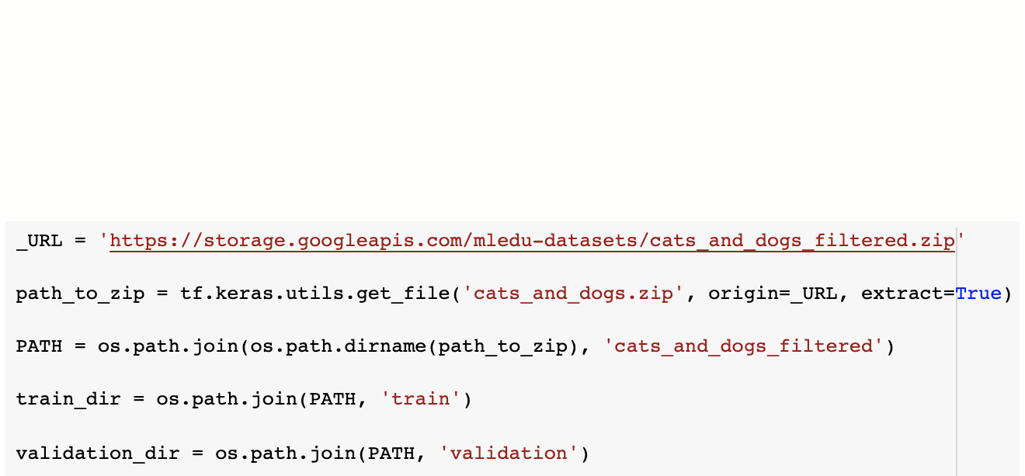

ImageDataGenerator in TensorFlow/ Keras. Use data augmentation techniques to randomly flip, rotate and zoom the training dataset using ImageDataGenerator. Use the TensorFlow Hub for transfer learning.

- Download the “Cats and Dogs” dataset using the following code. You can find this code in TensorFlow tutorial for image classification.

- Design and train a convolutional neural network for this dataset. Show the training and validation accuracy curves for each epoch. Apply various data augmentation techniques using ImageDataGenerator to reduce the overfitting.

- Install TensorFlow Hub and use “MobileNet” model as a feature extractor to implement transfer learning on “Cats and Dogs” dataset. Show the training and validation accuracy curves for each epoch. use following url to access “MobileNet” model. Compare results against previous model.

https://tfhub.dev/google/tf2-preview/mobilenet_v2/feature_vector/4

- Use “ResNet V2 50” and “ResNet V2 101” models from TF Hub as a feature extractor and compare the results against MobileNet.

Refer to: (TensorFlow tutorial on transfer learning with TF Hub)
1. Transfer learning with TensorFlow hub (https://www.tensorflow.org/tutorials/images/transfer_learning_with_hub)
2. Transfer learning with a pretrained ConvNet (https://www.tensorflow.org/tutorials/images/transfer_learning)

